How to Obtain the Photo Gallery APP ID

Firebug – Firefox

Download Firebug

1. Open Firefox
2. Visit <https://addons.mozilla.org/en-US/firefox/addon/firebug/>
3. Click ‘+ Add to Firefox’



1. Follow the on screen instrctions

Obtaining the APP ID with Firebug

1. Log into Site Manager
2. Open the Workspace containing the Photo Gallery of which you would like the APP ID.
3. Go to the ‘Tools’ tab
4. Go to ‘App Manager’
5. Go to ‘Photo Gallery’
6. Right click the App Instance and choose ‘Inspect Element with Firebug’

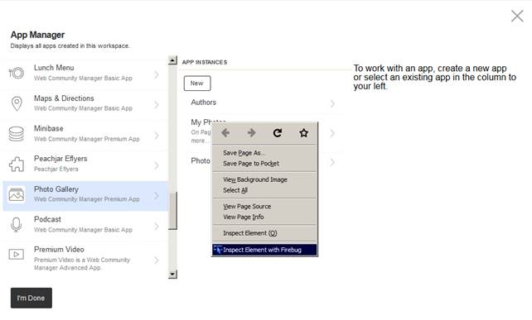

1. In this case the APP ID (a.k.a. the Module Instance) is ‘2996’ and is located in the highlighted code:  
   <a onclick="SelectNodeAM(this);Load**ModuleInstance**DetailAM(**2996**);">

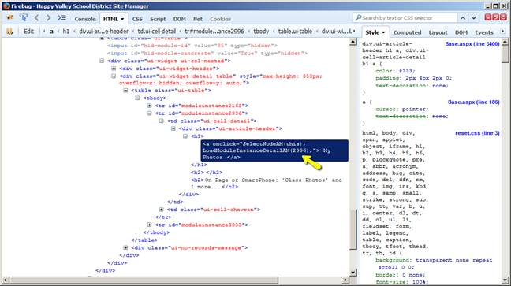

Developer Tools – Chrome

Obtaining the APP ID with Developer Tools

1. Log into Site Manager
2. Open the Workspace containing the Photo Gallery of which you would like the APP ID.
3. Go to the ‘Tools’ tab
4. Go to ‘App Manager’
5. Go to ‘Photo Gallery’
6. Right click the App Instance and choose ‘Inspect’

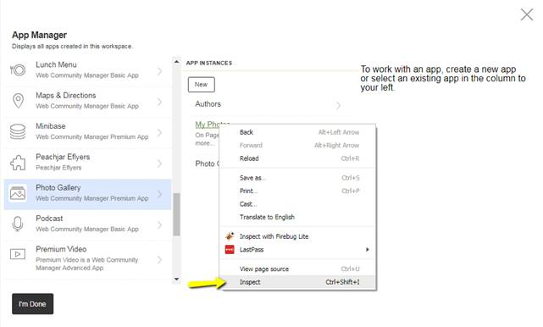

1. In this case the APP ID (a.k.a. the Module Instance) is ‘2996’ and is located in the highlighted code:  
   <a onclick="SelectNodeAM(this);Load**ModuleInstance**DetailAM(**2996**);">

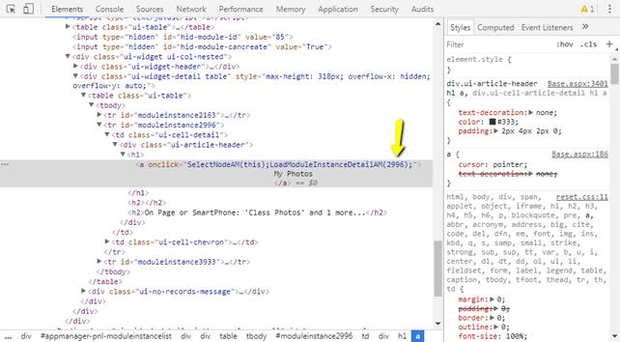

How to embed the APP ID onto a page

Place the following code into a Content App or other instance of the Tiny MCE Editor:

<div align="center">[$APP ID=2996$]</div>